**UNIVERSITI MALAYSIA TERENGGANU**

**Faculty Of Computer Sciences and Mathematics**

**Front End Programming**

**CSM3103**

Lab Report 4

**Prepared by:**

Muhammad Imran Bin Abd Hamid (S66803)

Bachelor of Computer Science (Mobile Computing) with Honors.

Sem 2 2023/2024

Task 1: JavaScript Function

Output:

Task 2: JavaScript Recursion Function

Output:

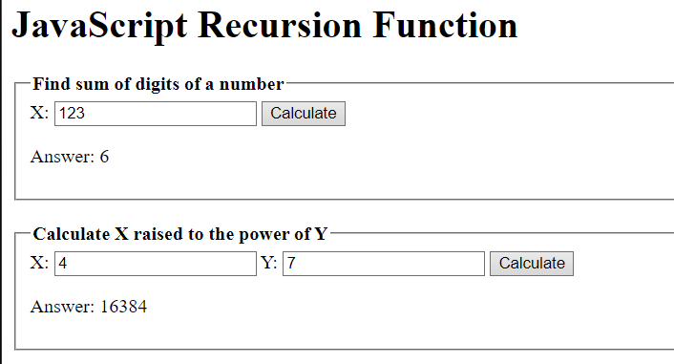

Task 3: JavaScript Object and Prototype

Output:

Task 4: Event Manager

Output:

Default:

On click:

On double click:

On mouse over:

On mouse out:

On change:

On focus:

On blur:

Task 5: Table

Output:

Click on Fateh Yakin row:

Click on Mukhriz Jamil Asoka row:

Click on Ismail Faisal row:

Task 6: Square

Output:

Link Github: <https://github.com/S66803/CSM3103-Front-End->